Timeline of events Virginie Fanny Dulloo and her husband Jean-Francois Dulloo
- 7th January 2025 (Our Wedding Anniversary). Received a call out of the blue from Jean-Francois at 9:32 am. He never really calls me so it was very unusual to receive a call.
- I asked Jean-Francois how he is then he cut me off stating “ Vida, The NDIS investigators are at our house and have forced themselves in telling Virginie she has no choice but to speak to them and that they have been there a for some time now.
- Jean-Francois continued to say “ can you please call her ASAP and help her.
- I said to Jean-Francois that I am not sure what I can do from over seas but sure, I am happy to call her.
- I called Virgnie’s phone but the line was cut and there was no answer. I did not call her back as I assumed she would be with NDIS investigators already and did not want to intervene in the investigations or interrupt anything that would bring further issues for Virginie.
- I messaged Jean-Francois back at 9:48 am and I stated “ I tried to call her but she is not answering”, he replied back with “ok”.
- At 10:07 am Jean-Francois called me back stating that Virginie was really shaken when she called him earlier and he doesn’t know what to do and he believes we should know what is happening. The call only lasted 22 seconds. I thanked him. He said he is on his way home and will call me back when he gets there.
- At 10:39 AM Jean-Francois called me back via video call with Virgnie and we spoke for 17 min 40 seconds.
- The call started with Jean-Francois saying the NDIS investigators have just left and it’s now just them at the house.
- I could see and hear Virginie in the background yelling, crying saying she can’t go through this again and she appeared very distressed, scared and shaken. She was walking around in circles.
- Jean-Francois stated to Virginie we have to talk to Vida and Simon because it was their company and they should help you.
- Virginie stated “no one will help me, she will not help, NDIS is going to throw me in jail now”.
- I stated to Virginie “ Hi Virginie, I’m really sorry you are going through this right now, no one deserves this. I am willing to help you as best as I can. Can you please tell me what is going on?”
- Virginie calmed down a little bit and stated “ John Maloney and a female NDIS investigator who refused to/did not provide her name was at her house and they interrogated her for 2 hours roughly.”
- Virginie continues to state that the investigator John Maloney stated to her “ I have enough evidence to put forward to the DPP and throw you in prison, unless you are willing to sign under this statement and give us what we want”
- Virginie stated that John Maloney continued to tell her “ We know Vida is a liar and a manipulative person, she is horrible and we want you to help us throw her in prison. You can work with us and there will be no consequences for you or we can put your face all over the news like we did to Vida very publicly.”
- Virgine stated she responded to John Maloney with “Can I please get some legal advice first and get back to you?”
- Virginie stated John Maloney responded with “ you have 24 hours to make up your mind. We have enough evidence to give to the dpp and throw you in prison for a very long time unless you give me a statement i can use against Vida Reid. We know Vida is in Bali and is not coming back. we have been listening to all your phone calls with Vida and are continuously monitoring Vida's movements, calls and messages and are aware you haven't been speaking to her for a while. you can protect yourself and give us a statement or you go to jail, which is it going to be? you have until tomorrow to call this number....... or we will proceed with prosecuting you" It’s your neck or her neck ( referring to Vida), what’s it going to be?”
- Virginie stated she kept quiet and the investigators continued with asking her some more questions about FFG, Vida and her own previous NDIS company which she was a director of called Dream BIG.
- Virginie stated she does not recall all of the questions asked as she was highly frightened being threatened and answered questions as best as she could in order to get them to leave her house.
- Virginie and her husband jean- francoise then asked me and simon if we can pay for her to get some legal advise and we agreed.
- I stated to Virginie to wait until I ask for some help and see what I can do and I will message or call her back.
- We sought advise from Weeks and co and also Tom Monks.
- I received 3 different suggestions from weeks and co to pass on to Virginie
- And Tom Monks agreed to just call her to tell Virginie her rights but stated he does not know if he is able to represent her.
- I messaged Virignie and advised her they cannot threaten her to coerce to sig a false statement and threaten her with prosecution.
- Virginie sent me messages stating what the NDIS investigator John Maloney has sent her and I have attached it at the bottom of this letter (Annexure A)
- I stated to Virginie to pick a lawyer of her choosing and one that is not representing me and I am happy to cover her consultation fees so that she understand her rights.
- I then called Virginie at 13:58 pm just to check and see how she is. Virginie asked me if I was willing to cover the whole cost of her legal battles if they try to prosecute her. I stated to Virginie to please not panic and remain as calm as she can because governments can’t just threaten innocent people with prison just to obtain a false statement and that I was willing to help her to best of my ability. I asked her to go see a wye and send me the bill but to date I have not received any bills or further messages.
- On January 11th 2025 Virginie messaged me to say Happy Birthday and I did to her as we share the same birthday!
- That is the last time so far I have spoken to her.
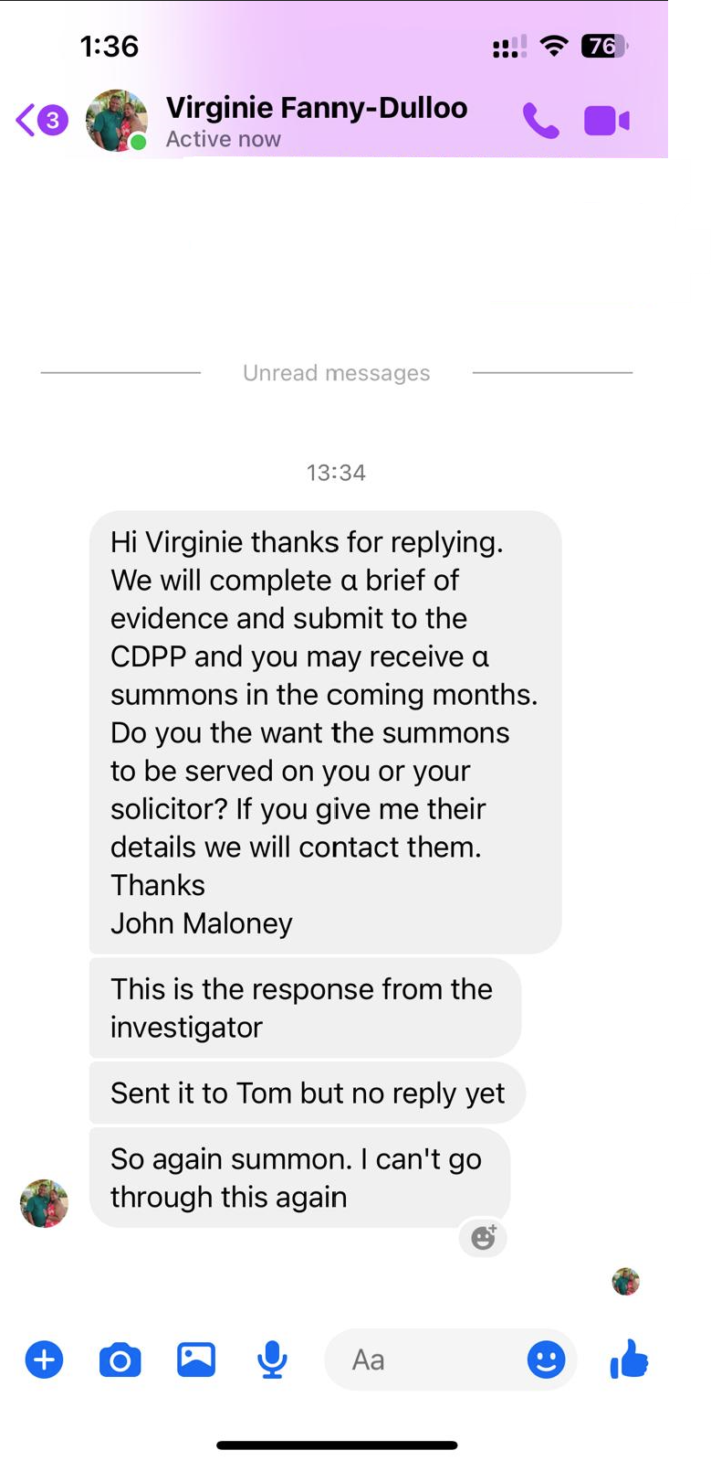
Annexture A

